**Agreement**

Coding Style

* Variables and function named with respect to their use and with camelCase.
* Indentation of variables to vertically align them

Project Structure

<https://github.com/Shadowdragonzz/Cool-Engine/tree/Assignment>

Minimum PC Requirements

* More than a potato

**Component Architecture Description**

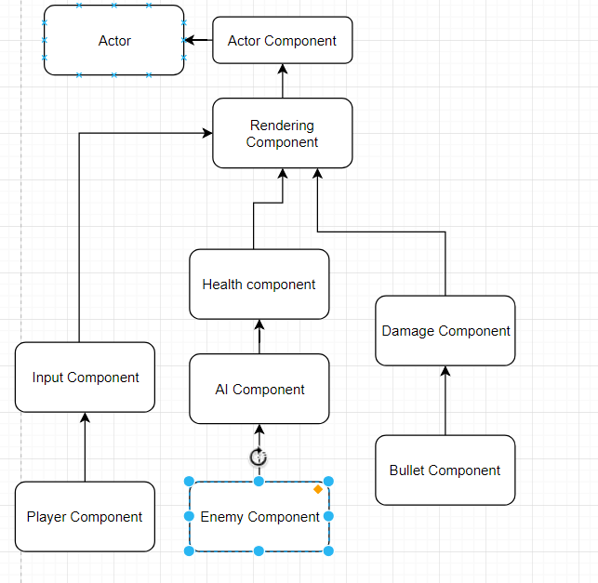

**UML Class Diagram**